**Section2**

**PL/SQL 2.1:**

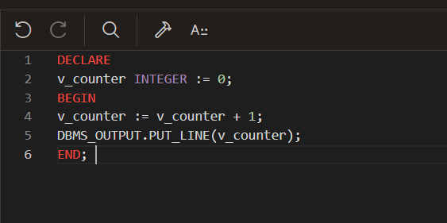

**PL/SQL 2.2:**

**PL/SQL 2.4:**

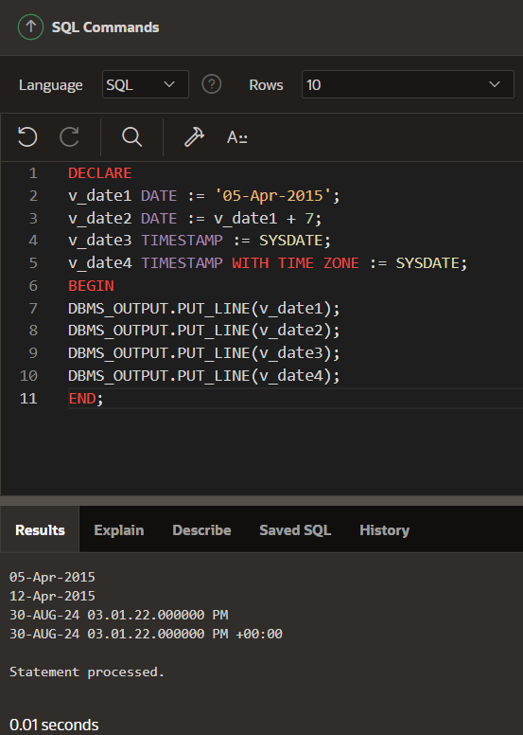

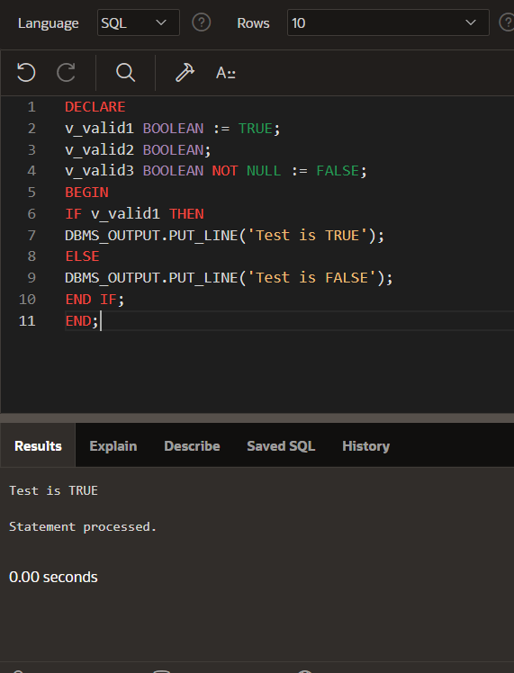

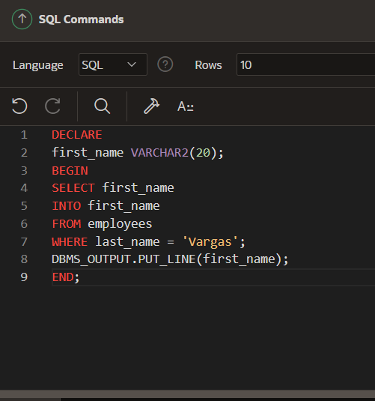

**PL/SQL 2.5:**

**PL/SQL 2.6:**

